**How to create a free AWS cloud account?**

**Step 1**: Navigate to ***https://aws.amazon.com/.*** The first screen you will view:

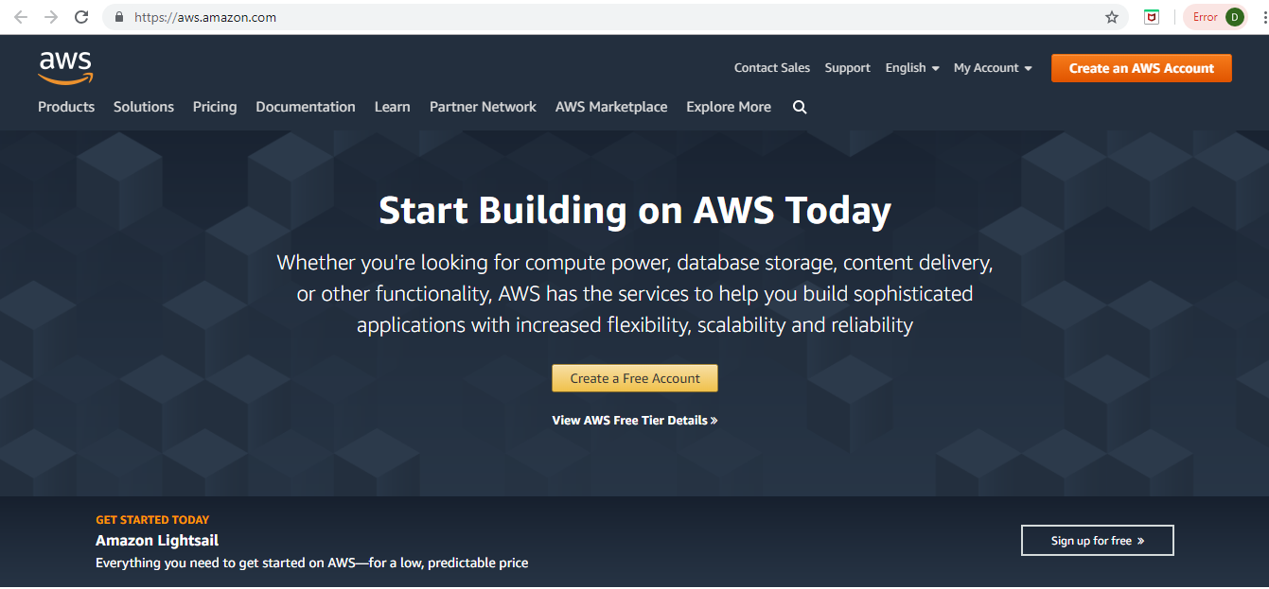

**Step 2**: Go to MyAccount dropdown and click on AWS Management Console.

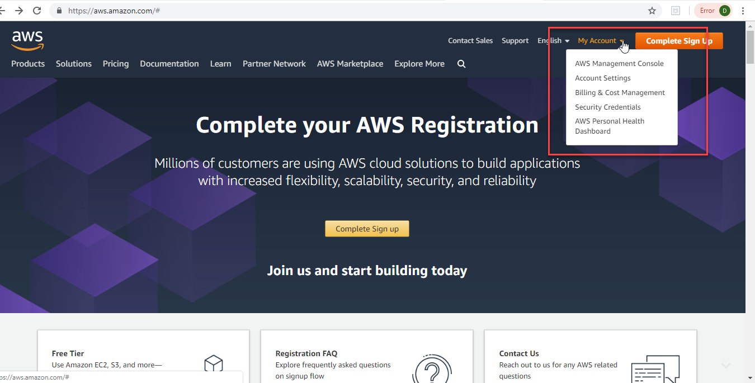

**Step 3:** You landup on this screen to sign in. Click on Create a new AWS account.

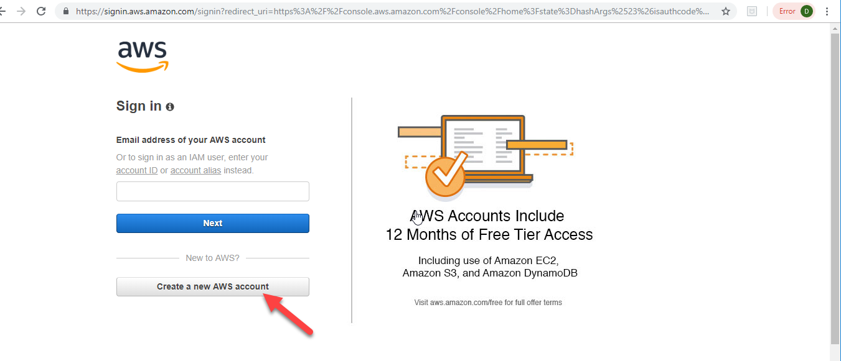

**Step 4:** Enter the details below and click Continue.

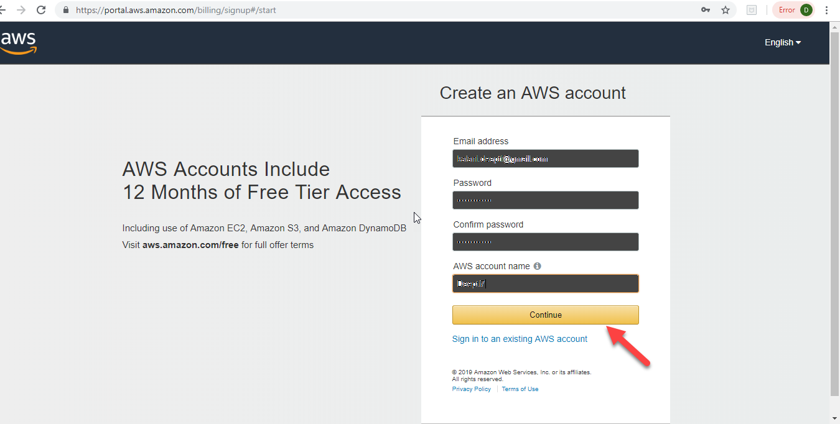

**Step 5:** Select the Account type as Personal and enter the details. Select your Country from the dropdown.

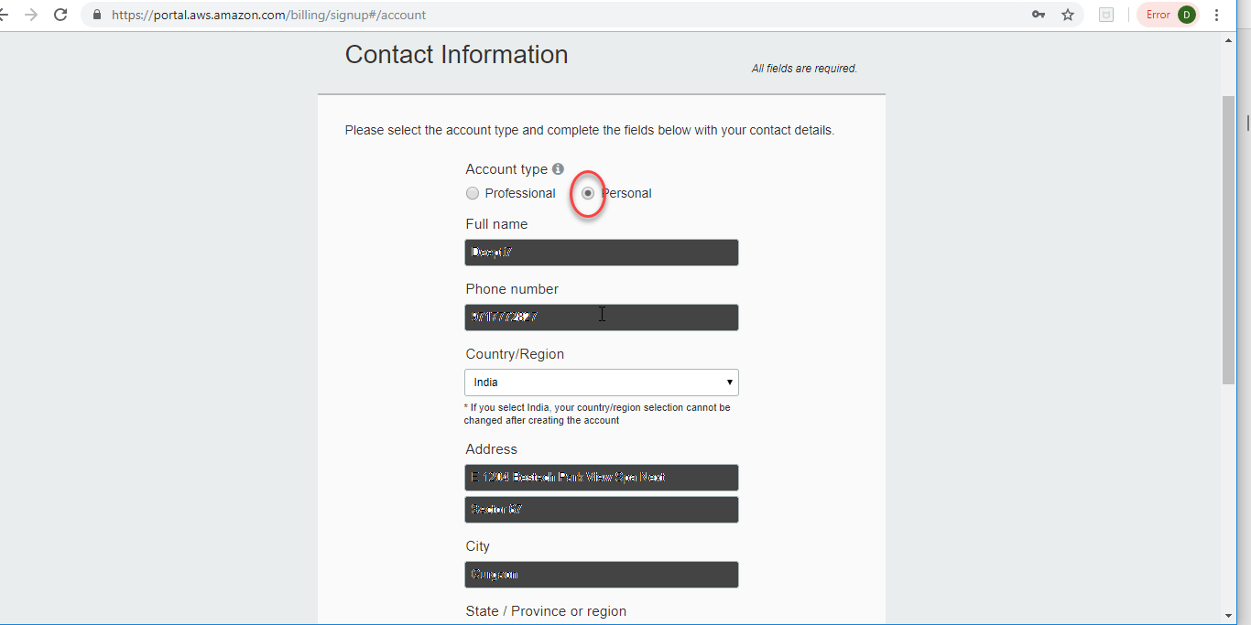

**Step 6:** Enter the details and click the check here checkbox and Create Account and Continue.

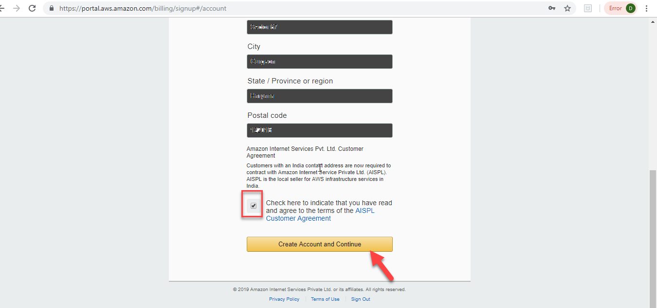

**Step 7:** Complete the Payment Information. Though, it is a free trial account, you need to enter a card details for identification/verification purpose.

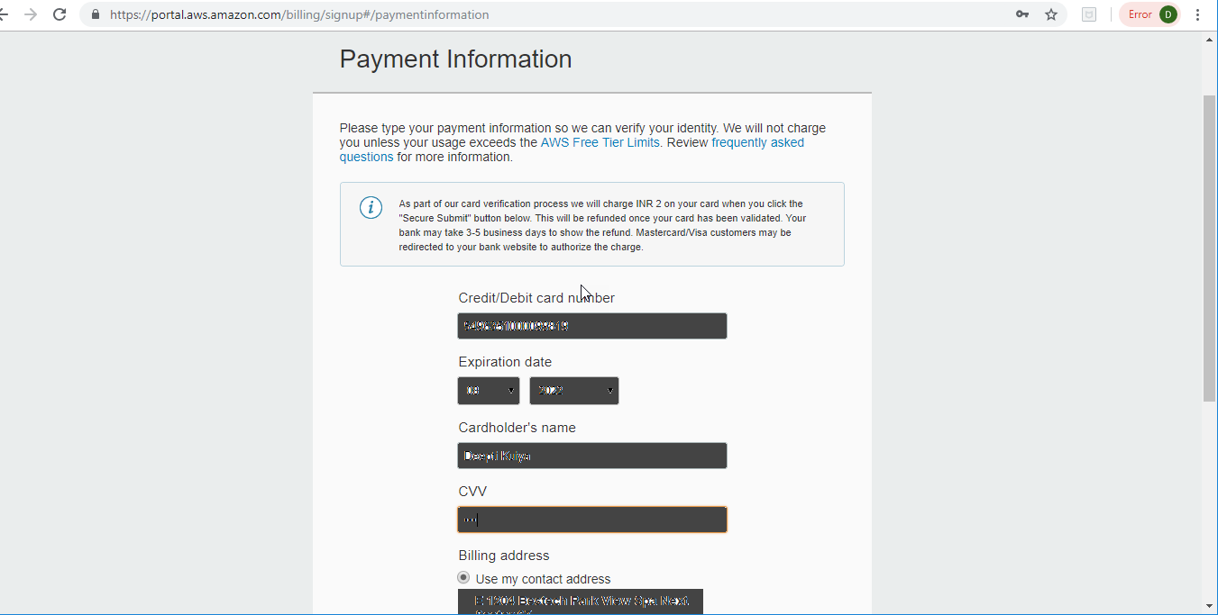

**Step 8:** Fill the required information and click Secure Submit.

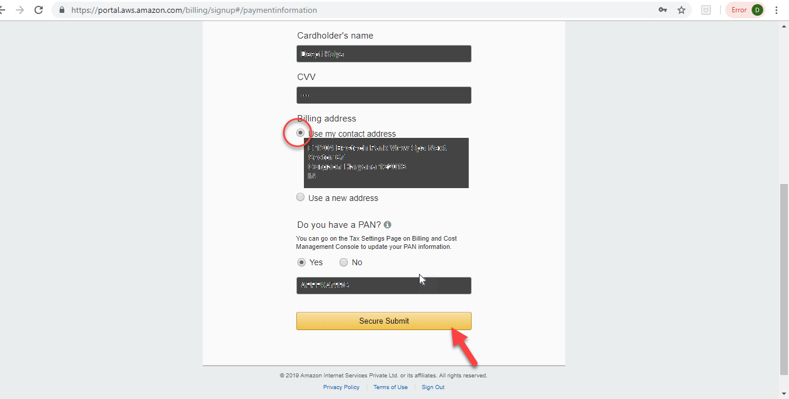

**Step 9:** Once the payment process is completed, you will view this screen. Fill in the appropriate details and click Contact me.

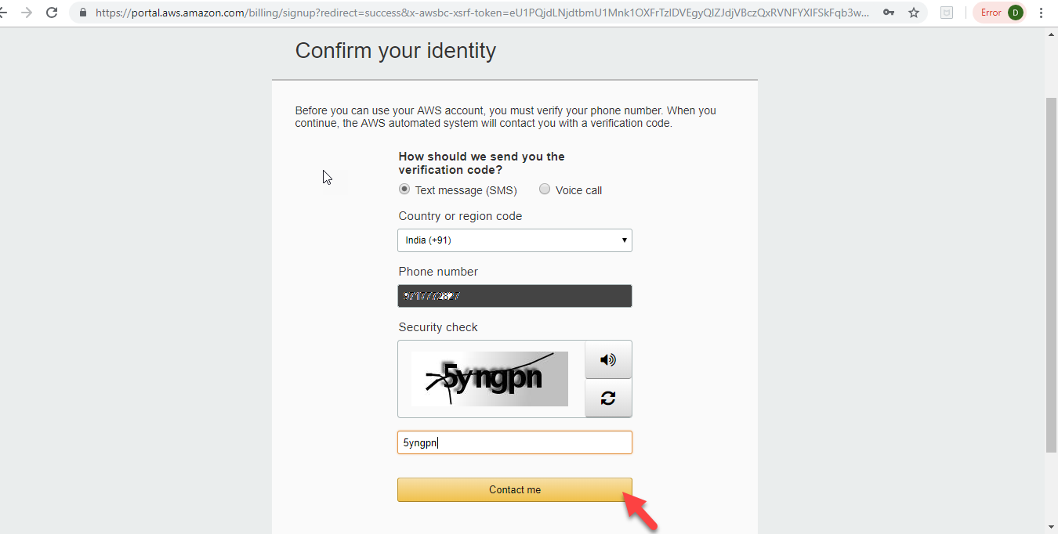

**Step 10:** Enter the verification code as received on the given mobile number and click Verify code.

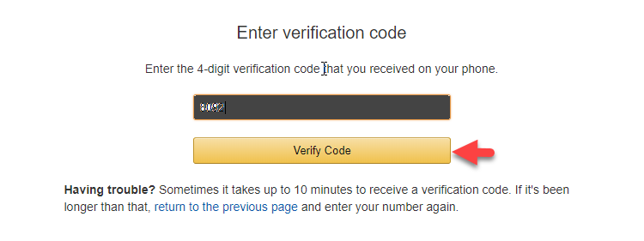

**Step 11:** You will view the below screen.

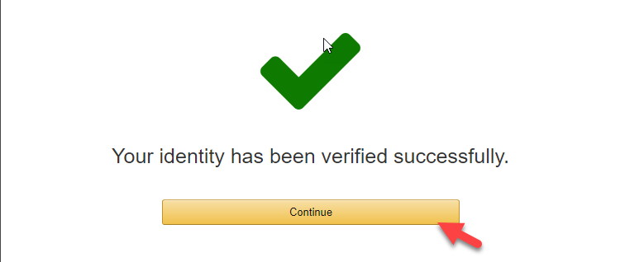

**Step 12**: Choose the Basic Plan by clicking Free button on the screen as below.

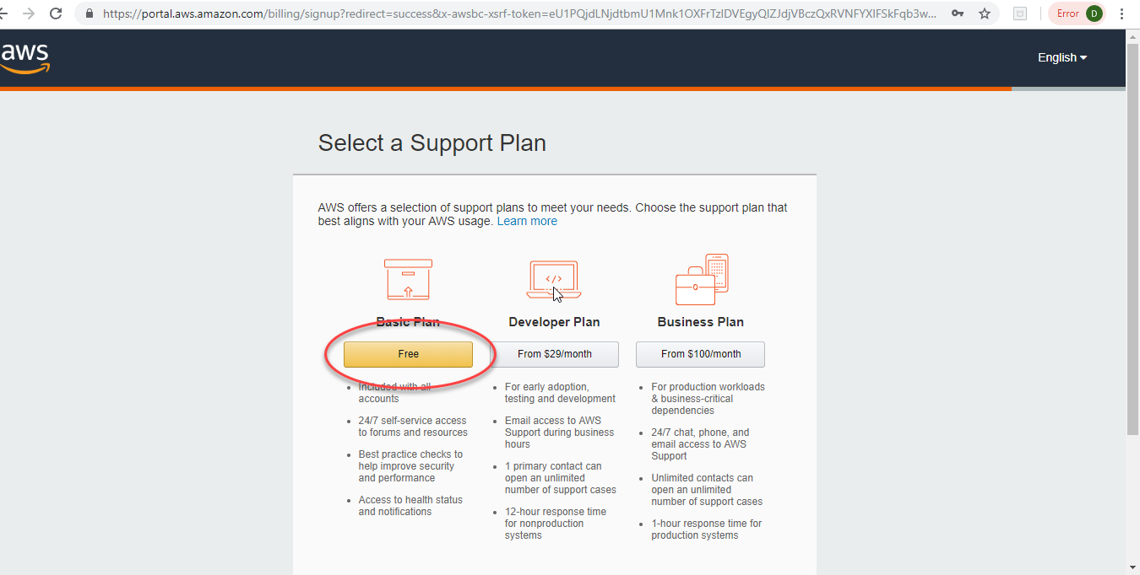

**Step 13:** You have successfully created your AWS free account. You should see this welcome screen.

